

Enterprise Systems and Architecture

Continuous Assessment

Assignment 2



DT282

BSc in Computer Science

(International)

**Jake Young**

**C14706715**

**DT282/4**

**Due Date: 29/04/2018**

A large percentage of organisations utilise some form of cloud computing model. In terms of Enterprise Systems such as ERP’s, SCM’s and CRM’s and the functionality they provide, what can an organisation expect to have available to them through these models, how does it provide advantages over ‘in-house’ implementations and what are the particular issues and risks involved in moving to cloud delivered business systems.

Cloud computing is the ability to store and access data and different programs over the internet. Storing data over the internet is known as storing on the cloud. This is a relatively new way of data storage compared to the more traditional method which was, storing data on your computer system. Therefore, cloud computing doesn’t mean storing data physically in a cloud, it is more of a metaphor for storing data on the internet.

“If someone asks me what cloud computing is, I try not to get bogged down with definitions. I tell them that, simply put, cloud computing is a better way to run your business”

(Marc Benioff, Founder, CEO and Chairman of Salesforce)

Since cloud computing is a relatively new topic of conversation which is not yet fully discovered nor is it completely understood by all, this means the cloud computing doesn’t yet have one set model. It is still up for interpretation. All of the cloud computing models can be mapped with three specific layers; Infrastructure Cloud, Platform Cloud, and Application Cloud.

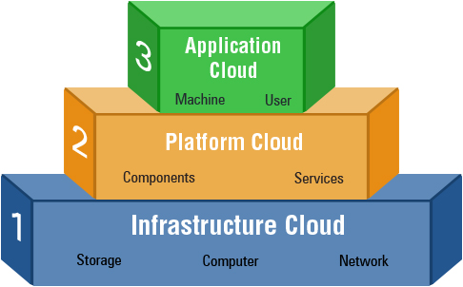

Figure A – Diagram of the Cloud Computing Model

The infrastructure cloud which is also known as IaaS. This stands for Infrastructure as a Service. This cloud provides the storage facility for the cloud. It is also responsible for dispersal of the cloud’s resources as a service for use by developers. IaaS is used by many enterprises as it eliminates the headache of having to setup data centres to hold the enterprises data. IaaS is a great way of adding value to and enterprise through capital saving, scalability, privacy, and reliability.

Infrastructure as a Service (IaaS) comes with the following characteristics;

* Resources distributed as a service
* Dynamic ability to scale resources
* Concurrent users on a single piece of hardware

Infrastructure as a Service (IaaS) comes with many advantages in terms of its effect on the organisation such as the following:

* The organisation is responsible for the maintenance of the software.

Since this cloud platform only provides the infrastructure, it is solely up to the organisation to take care of the maintenance and upgrading of the software developed.

* This layer allows for various different pricing models. Since a lot of great software is quite costly, this layer allows for payment of what the users use only.

This method allows users or start-up businesses to use strong software which before would have been an unobtainable option due to capital restrictions.

* The Infrastructure as a Service (IaaS) may give the business better security measures which are probably more secure than the businesses original security measures.

“In-House” security is nearly always less secure and not as up to date as the IaaS security. Therefore, for the most part, it is better to go with the Infrastructure as a Service (IaaS) security measures instead.

The second layer of the cloud computing model which is also the middle layer is known as the Platform as a Service layer, which has a shorthand version known as PaaS. Platform as a Service delivers environments for developing and operating as a service. This middle layer includes many tools and services created to assist developers in coding and deploying their application in a quick turn around and efficient way. This layer has a main responsibility of development and deployment of software only, which will be created over the web. An example of this layer being utilized in a business may be SalesForce.

Similarly, to IaaS, PaaS also comes with its own unique characteristics for its layer which are the following;

* Individual environment to do development, testing and deployment of applications
* Web-based user interface design tools to create, test, and deploy different scenarios
* OS and cloud programming API’s to create application which are cloud ready

The last layer of the cloud computing model which is the top layer of the model is the Software as a Service layer. Similarly, to the Platform as a Service (PaaS), Software as a Service (SaaS)is also a very functional layer. This type of cloud acts almost like a server in the sense that this cloud delivers an application through the browser to multiple users. This is done through using a multitenant architecture. In Software as a Service (SaaS), the application owner rents out his licence to use the application on a subscription basis or a certain period of time to consumers. Since there is only one application running, the costing of using this type of cloud is pretty low. An example of the Software as a Service (SaaS) may be SRM, or ERP.

Some of the characteristics of Software as a Service includes the following;

* Main application which is web-based, which is release to users on a subscription basis
* No issues regarding software upgrading or maintenance as they are taking care of by the service provider
* API’s allow for integration between different applications

An enterprise system is essentially the overall combination of computer hardware and software that an enterprise uses to run their overall operation of their business. Many enterprise systems are responsible for handling the large volumes of data which a business owns.

“Enterprise systems are software applications that have cross-organizational capabilities as opposed to department or group-specific programs. They allow for collaboration and communication across the organization through collection of data that is accessible and usable by multiple departments”

(www.techwalla.com)

There are many different types of enterprise systems such as ERP’s, SCM’s, and CRM’s. All of these systems are unique in the sense that they all have different operations that they perform.

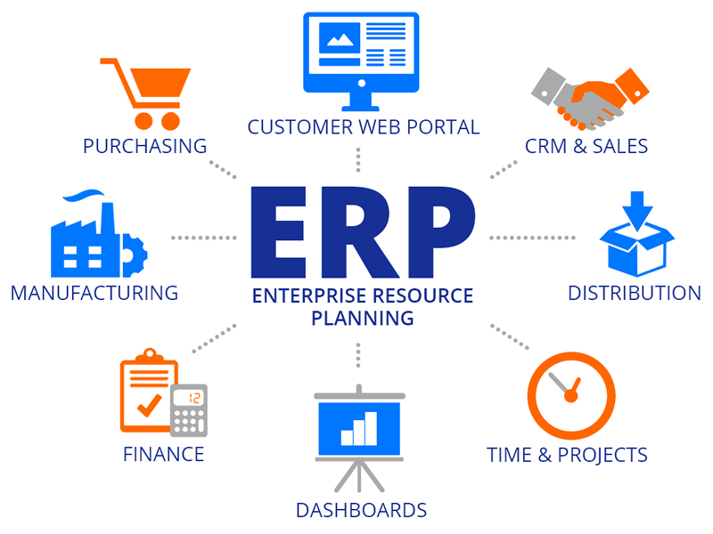

Figure B – Image of ERP

ERP stands for Enterprise Resource Planning. This type of enterprise software is responsible for the systems software packages which are used by the organisations to manage the businesses on a daily basis. Some of the tasks an Enterprise Resource Planning system (ERP) may be responsible for may be taking care of the project management side of a business, manufacturing, and accounting. Enterprise Resource Planning (ERP) are responsible also for interconnecting different process’ from within a business, which will allow smooth running of a business. Enterprise Resource Planning (ERP) are invaluable as they can manage large sums of data and filter through that data in order to remove duplicated data. This ensure the data’s integrity is less secured. Enterprise Resource Planning (ERP) are available for enterprises of all sizes.

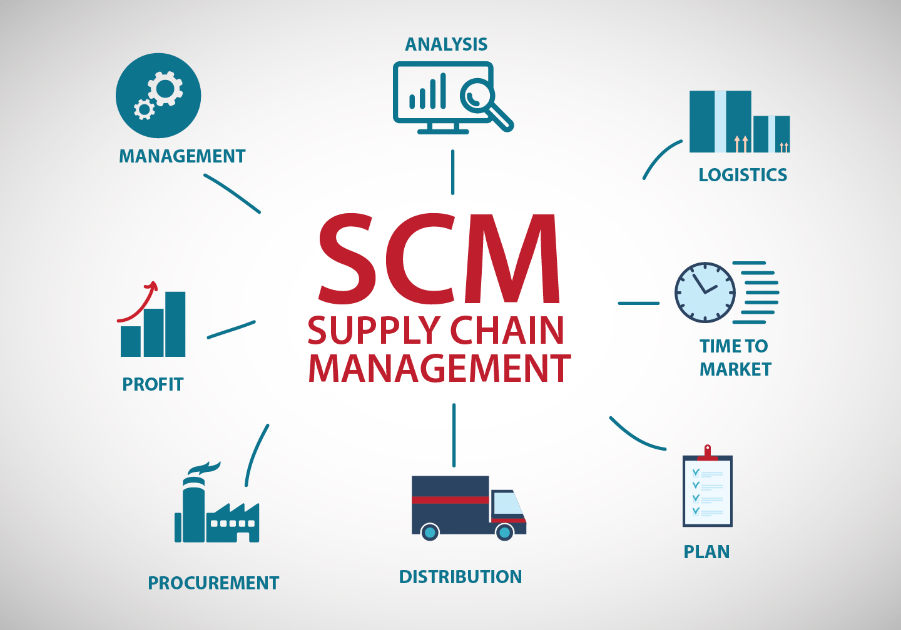

Figure C – Image of SCM

SCM’s are another type of enterprise system. SCM stands for Supply Chain Management. A supply chain refers to a list of tasks, data, people, or resources, etc. The management of the supply chain is in charge of all activities within the supply chain. Some of these activities may include the supply development, sourcing supplies, production of supplies, and strategy planning. The management of a supply chain ensures that the supply is being correctly managed by in terms of manufacturing, transporting, and selling of supplies.

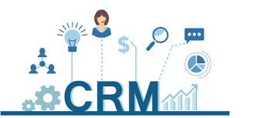

Figure D – Image of CRM

The other type of enterprise system is the Customer Relationship Management system (CRM). This type of system was developed in order to attempt to develop a relationship in the sales department with the customers. The use of Customer Relationship Management (CRM) ensured the sales department had a better and clearer understanding of the customer and the customer’s needs and wants. Through gathering this information, the sales team can market this gathered information in order to better market the business. Customer Relationship Management (CRM) doesn’t only work on relationships, it also works on the integration of the system with other systems. Customer Relationship Management (CRM) allows the sales process flow which greatly improves the employee productivity.